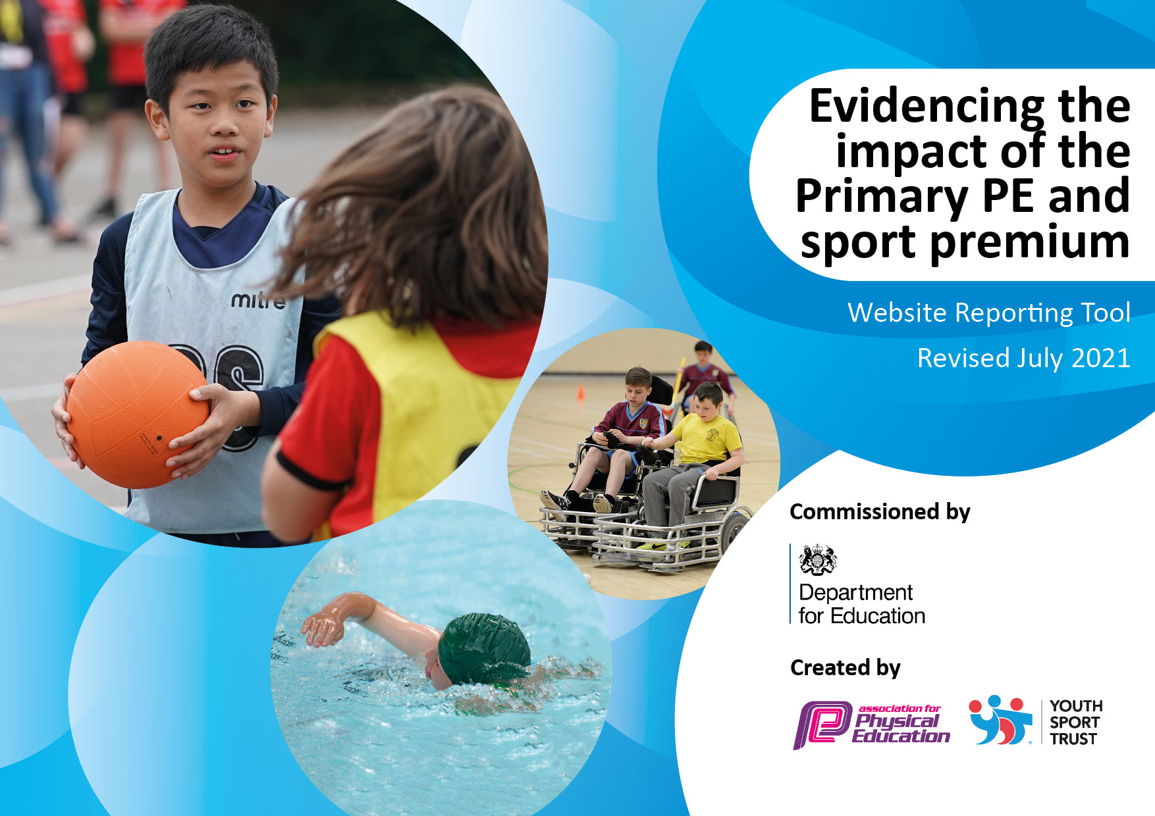
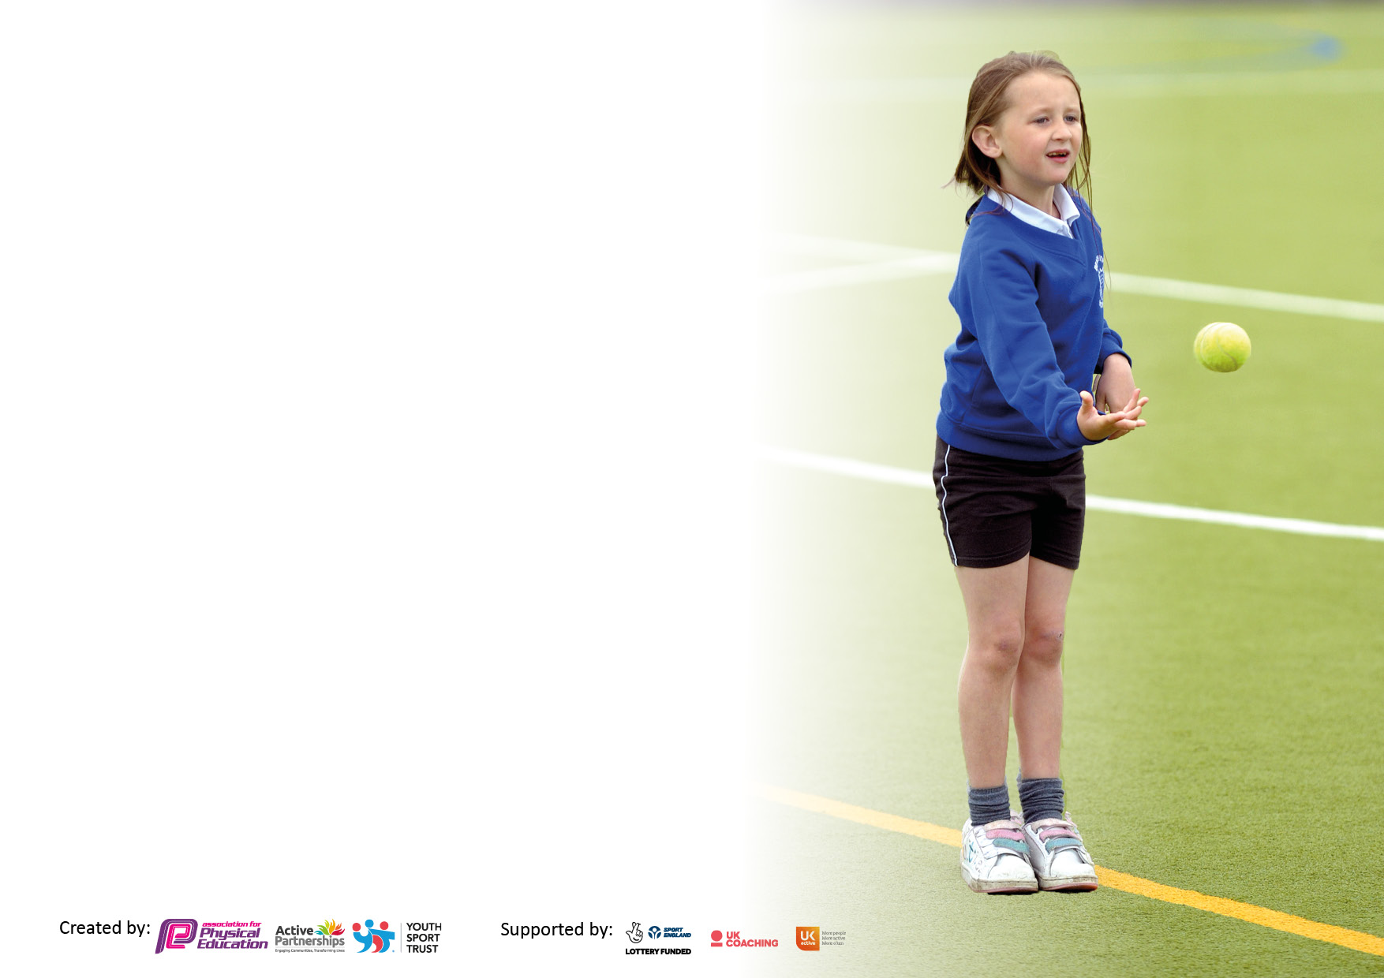

It is important that your grant is used effectively and based on school need. The Education Inspection Framework makes clear there will be a focus on ‘whether leaders and those responsible for governors all understand their respective roles and perform these in a way that enhances the effectiveness of the school’.

Under the Quality of Education Ofsted inspectors consider:
Intent - Curriculum design, coverage and appropriateness
Implementation - Curriculum delivery, Teaching (pedagogy) and Assessment
Impact - Attainment and progress

To assist schools with common transferable language this template has been developed to utilise the same three headings which should make your plans easily transferable between working documents.

Schools must use the funding to make additional and sustainable improvements to the quality of Physical Education, School Sport and Physical Activity (PESSPA) they offer. This means that you should use the Primary PE and sport premium to:

- Develop or add to the PESSPA activities that your school already offer
- Build capacity and capability within the school to ensure that improvements made now will benefit pupils joining the school in future years
- The Primary PE and sport premium should not be used to fund capital spend projects; the school’s budget should fund these.

Pleasevisitgov.ukfortherevisedDfEguidanceincludingthe5keyindicatorsacrosswhichschoolsshoulddemonstrate animprovement.Thisdocumentwillhelpyoutoreviewyourprovisionandtoreportyourspend.DfEencouragesschools to use this template as an effective way of meeting the reporting requirements of the Primary PE and sport premium.

We recommend you start by reflecting on the impact of current provision and reviewing the previous spend.

Schools are required to publish details of how they spend this funding, including any under-spend from 2019/2020, as well as on the impact it has on pupils’ PE and sport participation and attainment. All funding must be spent by 31st July 2022.

We recommend regularly updating the table and publishing it on your website throughout the year. This evidences your ongoing self-evaluation of how you are using the funding to secure maximum, sustainable impact. Final copy must be posted on your website by the end of the academic year and no later than the 31st July 2021. To see an example of how to complete the table please click HERE.


Created by: Supported by:

Details with regard to funding
Please complete the table below.

Total amount carried over from 2023/24 | £0
Total amount allocated for 2023/24 | £16,560
How much (if any) do you intend to carry over from this total fund into 2024/25? | £0
Total amount allocated for 2024/25 | £
Total amount of funding for 2024/25. To be spent and reported on by 31st July 2025 | £16560
Swimming Data
Please report on your Swimming Data below. Swimming is planned for May -July data to be added.

Meeting national curriculum requirements for swimming and water safety.

N.B. Complete this section to your best ability. For example you might have practised safe self-rescue techniques on dry land which you can then transfer to the pool when school swimming restarts.
Due to exceptional circumstances priority should be given to ensuring that pupils can perform safe self rescue even if they do not fully meet the first two requirements of the NC programme of study
What percentage of your current Year 6 cohort swim competently, confidently and proficiently over a distance of at least 25 metres?  N.B. Even though your pupils may swim in another year please report on their attainment on leaving primary school at the end of the summer term 2024.  Please see note above | %
What percentage of your current Year 6 cohort use a range of strokes effectively [for example, front crawl, backstroke and breaststroke]?  Please see note above | %
What percentage of your current Year 6 cohort perform safe self-rescue in different water-based situations? | %
Schools can choose to use the Primary PE and sport premium to provide additional provision for swimming but this must be for activity over and above the national curriculum requirements. Have you used it in this way? | We will give vouchers to be used in summer holidays

Action Plan and Budget Tracking
Capture your intended annual spend against the 5 key indicators. Clarify the success criteria and evidence of impact that you intend to measure to evaluate for pupils today and for the future.

Academic Year: 2024/25 | Total fund allocated:£16560 | Date Updated:Feb 14th 2025
Key indicator 1: The engagement of all pupils in regular physical activity – Chief Medical Officers guidelines recommend that primary school pupils undertake at least 30 minutes of physical activity a day in school |  |  |  | Percentage of total allocation:
 |  |  |  | 37%
Intent | Implementation |  | Impact
Your school focus should be clear what you want the pupils to know and be able to do and about  what they need to learn and to  consolidate through practice: | Make sure your actions to achieve are linked to your intentions: | Funding allocated: | Evidence of impact: what do pupils now know and what can they now do? What has changed? | Sustainability and suggested next steps:
Continue to provide a broader range of after school activities to ensure more children are regularly more physically active  Lunchtime MSA/Playleader to lead active play sessions. | After school sports club for Y1-6  (Including Village Hall hire )  Playleader MSA | 6192(cost of after school clubs and hall hire and lunch time) | These opportunities to participate in and become more physically active will improve physical fitness and support mental health and wellbeing.  Children can participate in positive, active playtimes which will support those children who aren’t able to make decisions about positive play. | Vary clubs offered to appeal to all children  Train all Y6 as Sports Leaders to help lead activities
Key indicator 2: The profile of PESSPA being raised across the school as a tool for whole school improvement
 |  |  |  | 60% total allocation
Intent | Implementation |  | Impact
Your school focus should be clear what you want the pupils to know and be able to do and about  what they need to learn and to  consolidate through practice: | Make sure your actions to achieve are linked to your intentions: | Funding allocated: | Evidence of impact: what do pupils now know and what can they now do? What has changed? | Sustainability and suggested next steps:
Regular celebration assemblies to share the importance of Physical activity/PE/Sport with all pupils.  Share results through Class Dojo/FB/Twitter  Annual sports day.Y6 children to plan and lead activities supported by sports lead  Forest School provided by Branch and Bloom | Achievements will be celebrated through assemblies. Children will be given opportunities to share their own achievements with their peers.  Sports Day medals  .  Two trained FS practitioners to plan and lead an exciting and inclusive | £60  £10,000 | Display of pupils’ achievements displayed and shared.  Community awareness of children’s achievements.  Children are proud to lead and support younger peers.  Outdoor learning has had a positive effect on mental health and well being | Continue with celebrations and sharing achievements.  Continue annually  Continue and review annually .Positive impact on SEMH as well as physical well being.

Key indicator 3: Increased confidence, knowledge and skills of all staff in teaching PE and sport |  |  |  | Percentage of allocation:  6%
Intent | Implementation |  | Impact
Your school focus should be clear | Make sure your actions to | Funding | Evidence of impact: what do | Sustainability and suggested
what you want the pupils to know | achieve are linked to your | allocated: | pupils now know and what | next steps:
and be able to do and about | intentions: |  | can they now do? What has
what they need to learn and to |  |  | changed?:
consolidate through practice:
Jasmine PE  Real PE Membership  WNDSSP membership | Online subscription  Support for teachers to teach a broad and balanced curriculum.  CPD and sports conference included in cost. | £413  £695  £3750*added below | Progression across ages and Key Stages will be clear and appropriate.  Support for PE lead and all teachers | Continue to purchase and review impact annually
Key indicator 4: Broader experience of a range of sports and activities offered to all pupils
Intent | Implementation |  | Impact | 28% of total allocation
Your school focus should be clear | Make sure your actions to | Funding | Evidence of impact: what do | Sustainability and suggested
what you want the pupils to know | achieve are linked to your | allocated: | pupils now know and what | next steps:
and be able to do and about | intentions: |  | can they now do? What has
what they need to learn |  |  | changed?
Provide opportunities for all children to compete widely in a range of sports-within our Trust and through WNDSSP organised events.  Sports Residential at Norfolk Lakes | Inter school and county wide competitions to give the children the experience of competing against children from a variety of different settings.  Year 5/6 children will experience a range of unfamiliar sports and take place in team building activities. | £3750  to include supply cover and any transport required.  £1000 towards cost of overall trip to make it affordable for all children. | Children will compete with confidence and demonstrate increased skills.  Children will experience new sports which will encourage them to explore further different clubs and opportunities offered to them. Increased self-confidence, | Continue with entering a variety of competitions .All children to represent the school at least once each year.  All children will be offered this trip during their time at Garvestone.
Additional achievements |  | £

Key indicator 5: Increased participation in competitive sport |  |  |  | Percentage of total allocation:
 |  |  |  | %
Intent | Implementation |  | Impact
Your school focus should be clear | Make sure your actions to | Funding | Evidence of impact: what do | Sustainability and suggested
what you want the pupils to know | achieve are linked to your | allocated: | pupils now know and what | next steps:
and be able to do and about | intentions: |  | can they now do? What has
what they need to learn and to |  |  | changed?:
consolidate through practice:
Children will develop new skills and enhance abilities through taking part in off-site sporting activities provided through WNDSSP  Children will take part in Trust wide activities. | Remain as a member of WNDSSP | £3750 -already counted above | Improved skills and positive engagement  Opportunities of working with children from different schools. | Continue with this package

Signed off by
Head Teacher: | Michelle Farnan
Date: | 8th September 2024/July 25
Subject Leader: | Janet Bazzoni
Date: | 8th September 2023/July 2025
Governor:
Date:

